**Introduction to Programming-2 (Python)**

# Yermek, Temirlan, se2218, 220063

ASSIGNMENT 6

Problem – a0  
  
my_bot.py (were changed only this part of code)

from random import randint

#import numpy as np

def name():

return "Bot-MY_BOT"

def main():

#board = np.full((6,7),0)

pass

def turn(board, p = 1, e = 2):

for col in range(7):

if can_win(board, col, p):

return col

for col in range(7):

if can_win(board, col, e):

return col

non_full_cols = [col for col in range(7) if isempty(board, col)]

return non_full_cols[randint(0, len(non_full_cols) - 1)]

def can_win(board, col, player):

test_board = board.copy()

row = 5

while row >= 0 and test_board[row, col] != 0:

row -= 1

if row < 0:

return False

test_board[row, col] = player

return is_winning_move(test_board, row, col, player)

def is_winning_move(board, row, col, player):

count = 0

for i in range(max(0, col - 3), min(4, col) + 1):

if board[row, i] == player:

count += 1

if count == 4:

return True

else:

count = 0

count = 0

for i in range(max(0, row - 3), min(2, row) + 1):

if board[i, col] == player:

count += 1

if count == 4:

return True

else:

count = 0

count = 0

i = max(row - 3, 0)

j = max(col - 3, 0)

while i <= min(row + 3, 5) and j <= min(col + 3, 6):

if board[i, j] == player:

count += 1

if count == 4:

return True

else:

count = 0

i += 1

j += 1

count = 0

i = max(row - 3, 0)

j = min(col + 3, 6)

while i <= min(row + 3, 5) and j >= max(col - 3, 0):

if board[i, j] == player:

count += 1

if count == 4:

return True

else:

count = 0

i += 1

j -= 1

return False

def isempty(board, col_j): # checks, is column's "col_j" top empty?

if board[0,col_j] != 0: return False # 1 or 2 atop

else: return True # 0 atop, we can put there

if __name__ == "__main__":

main()  
  
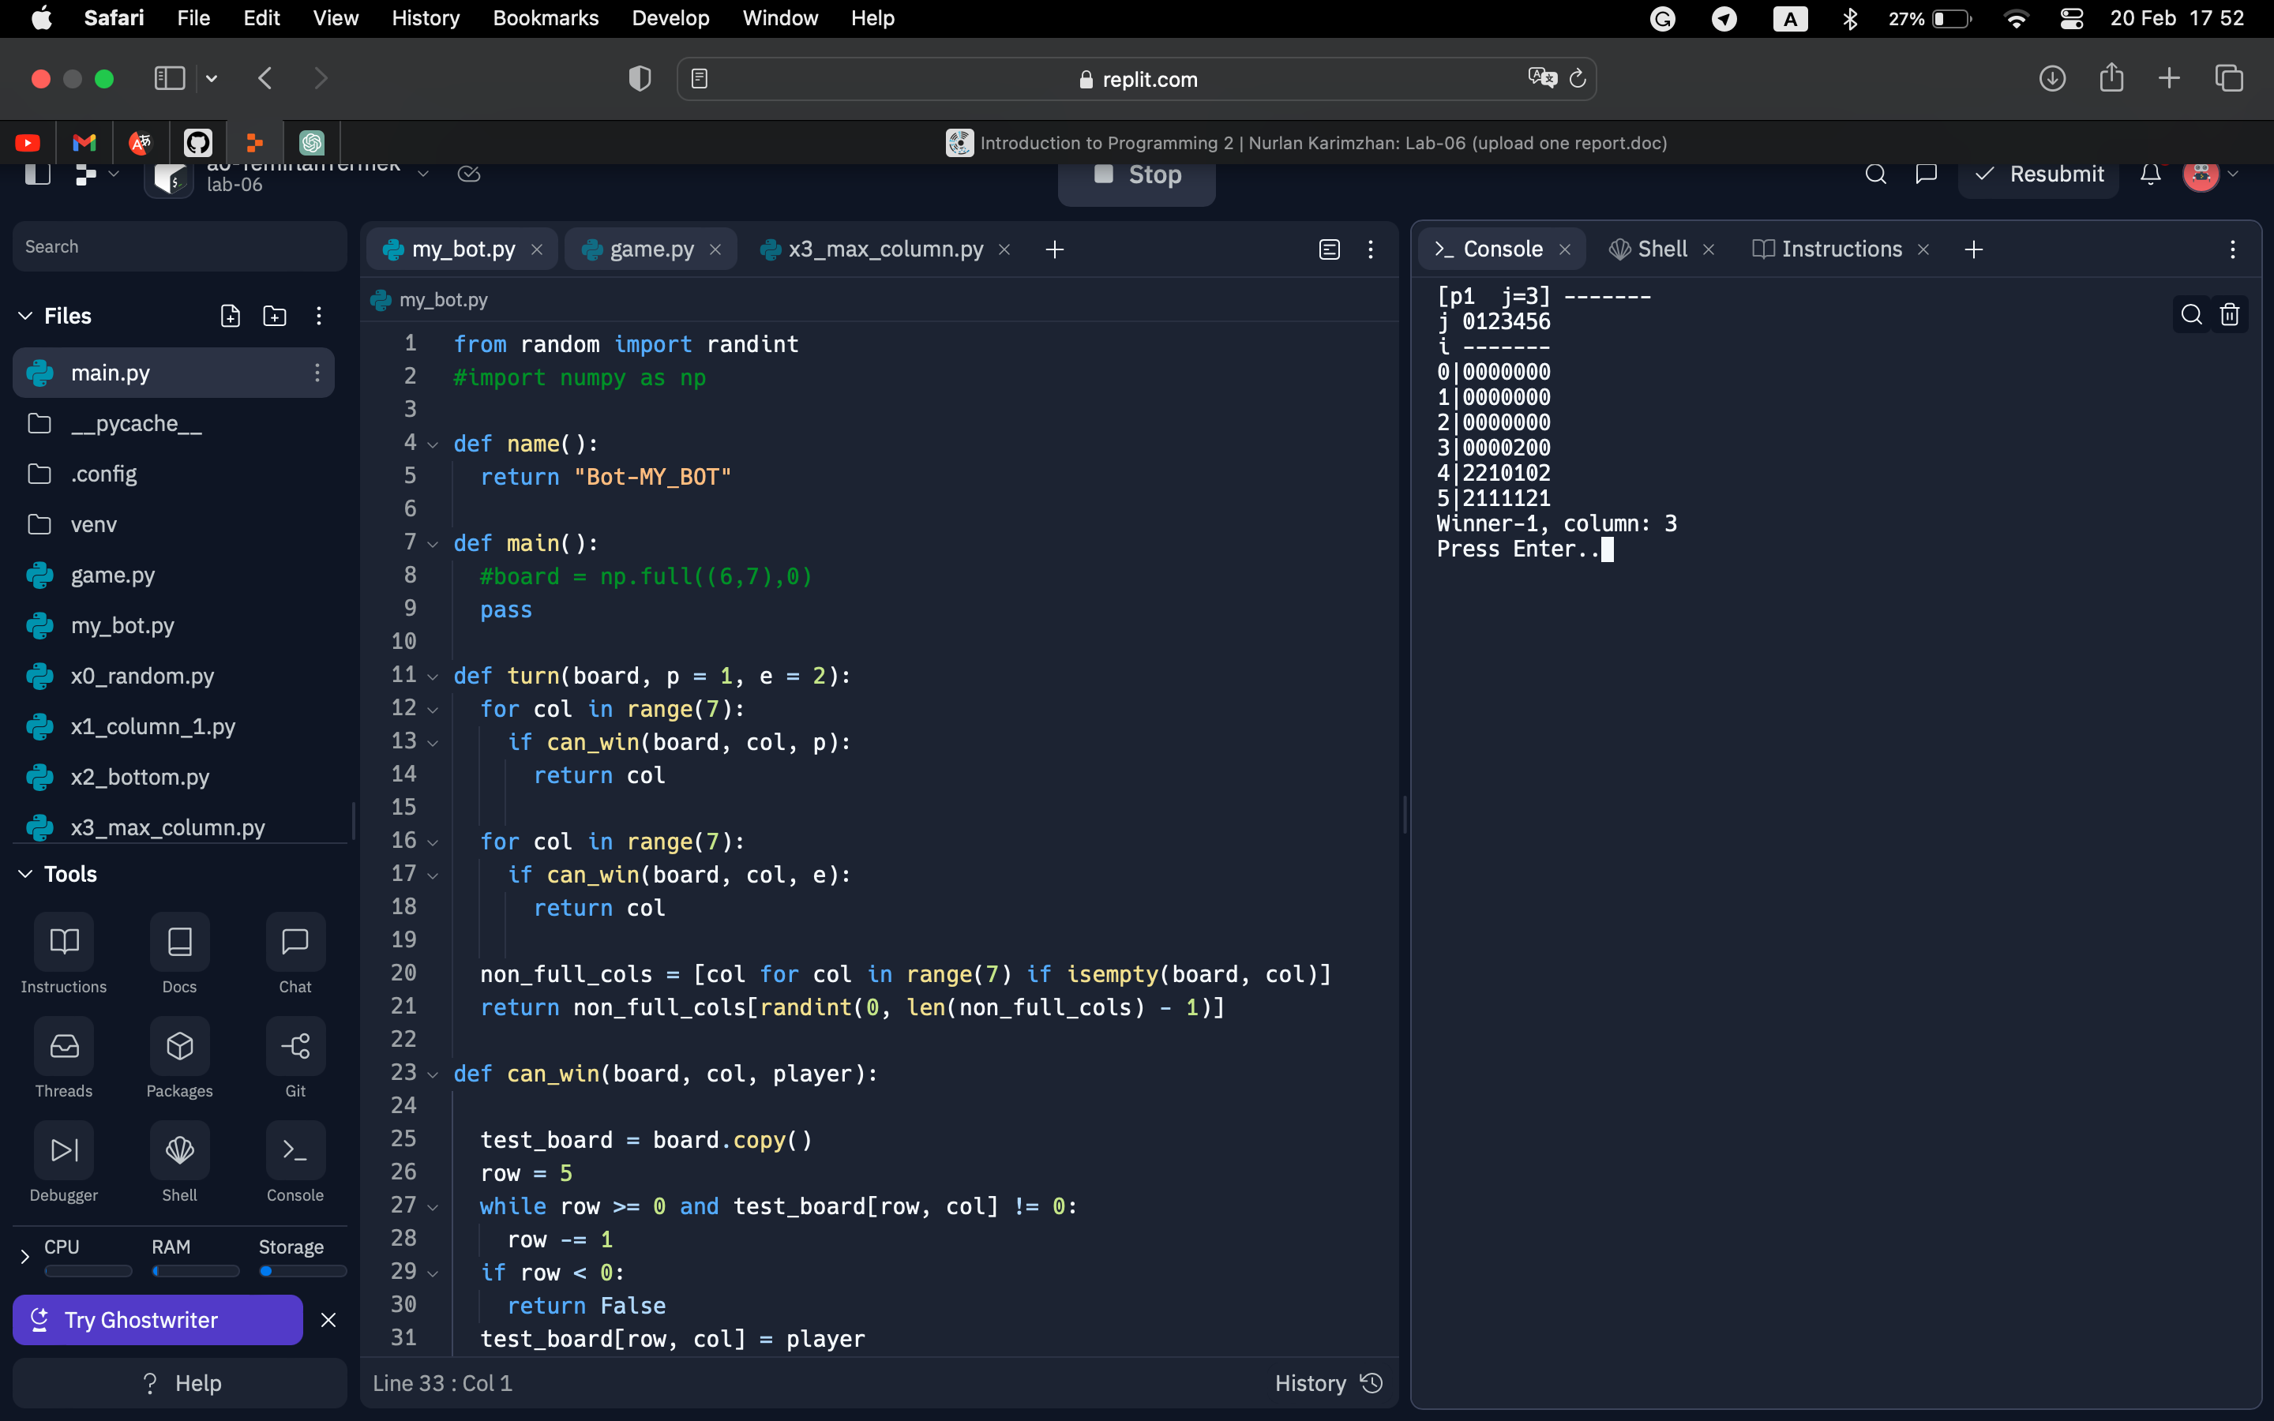

**Problem – a1**

import numpy as np

def read_file(filename):

with open(filename, 'r') as file:

lines = file.readlines()

matrix = np.zeros((len(lines), len(lines[0].split())), dtype=int)

for i, line in enumerate(lines):

matrix[i] = np.array([int(x) for x in line.split()])

return matrix

def print_matrix(matrix):

for row in matrix:

print(' '.join(str(x) for x in row))

def main_diagonal_mean(matrix):

diagonal = np.diag(matrix)

return diagonal.mean()

def second_diagonal_median(matrix):

diagonal = np.diag(np.fliplr(matrix))

return np.median(diagonal)

def sum_mean_median(filename):

matrix = read_file(filename)

print_matrix(matrix)

sum_value = main_diagonal_mean(matrix) + second_diagonal_median(matrix)

print('{:.1f}'.format(sum_value))

sum_mean_median('test-01.txt')

sum_mean_median('test-02.txt')

Problem – a2

import numpy as np

def read_file(filename):

with open(filename, 'r') as file:

lines = file.readlines()

matrix = np.zeros((len(lines), len(lines[0].split())), dtype=int)

for i, line in enumerate(lines):

matrix[i] = np.array([int(x) for x in line.split()])

return matrix

def print_matrix(matrix):

for row in matrix:

print(' '.join(str(x) for x in row))

def replace_diagonals_with_zero(matrix):

size = len(matrix)

for i in range(size):

matrix[i][i] = 0

matrix[i][size-i-1] = 0

return matrix

def save_to_file(matrix, filename):

with open(filename, 'w') as file:

for row in matrix:

file.write(str(row) + '\n')

def process_matrix(filename):

matrix = read_file(filename)

print_matrix(matrix)

matrix = replace_diagonals_with_zero(matrix)

print_matrix(matrix)

save_to_file(matrix, 'result.txt')

process_matrix('test-01.txt')

Problem – a3

import csv

import random

def main():

file_name = input()

if file_name == "":

file_name = "gpa.csv"

generate_csv_file(file_name)

print_avg_gpa(file_name)

def print_avg_gpa(file_name):

students = []

with open(file_name) as file:

reader = csv.DictReader(file)

for row in reader:

id = row["ID"]

group = row["GROUP"]

gpa1 = int(row["GPA1"])

gpa2 = int(row["GPA2"])

gpa3 = int(row["GPA3"])

gpa_avg = round((gpa1 + gpa2 + gpa3) / 3)

students.append({"ID": id, "GROUP": group, "GPA_AVG": gpa_avg})

for student in sorted(students, key=lambda student: student["ID"]):

print(f"{student['ID']}, {student['GROUP']}, {student['GPA_AVG']}")

def generate_csv_file(file_name):

with open(file_name, "w", newline='') as file:

writer = csv.writer(file)

writer.writerow(["ID", "GROUP", "GPA1", "GPA2", "GPA3"])

for i in range(10):

id = f"220{random.randint(100, 999)}"

group = f"SE-22{random.randint(10, 99)}"

gpa1 = random.randint(0, 100)

gpa2 = random.randint(0, 100)

gpa3 = random.randint(0, 100)

writer.writerow([id, group, gpa1, gpa2, gpa3])

main()

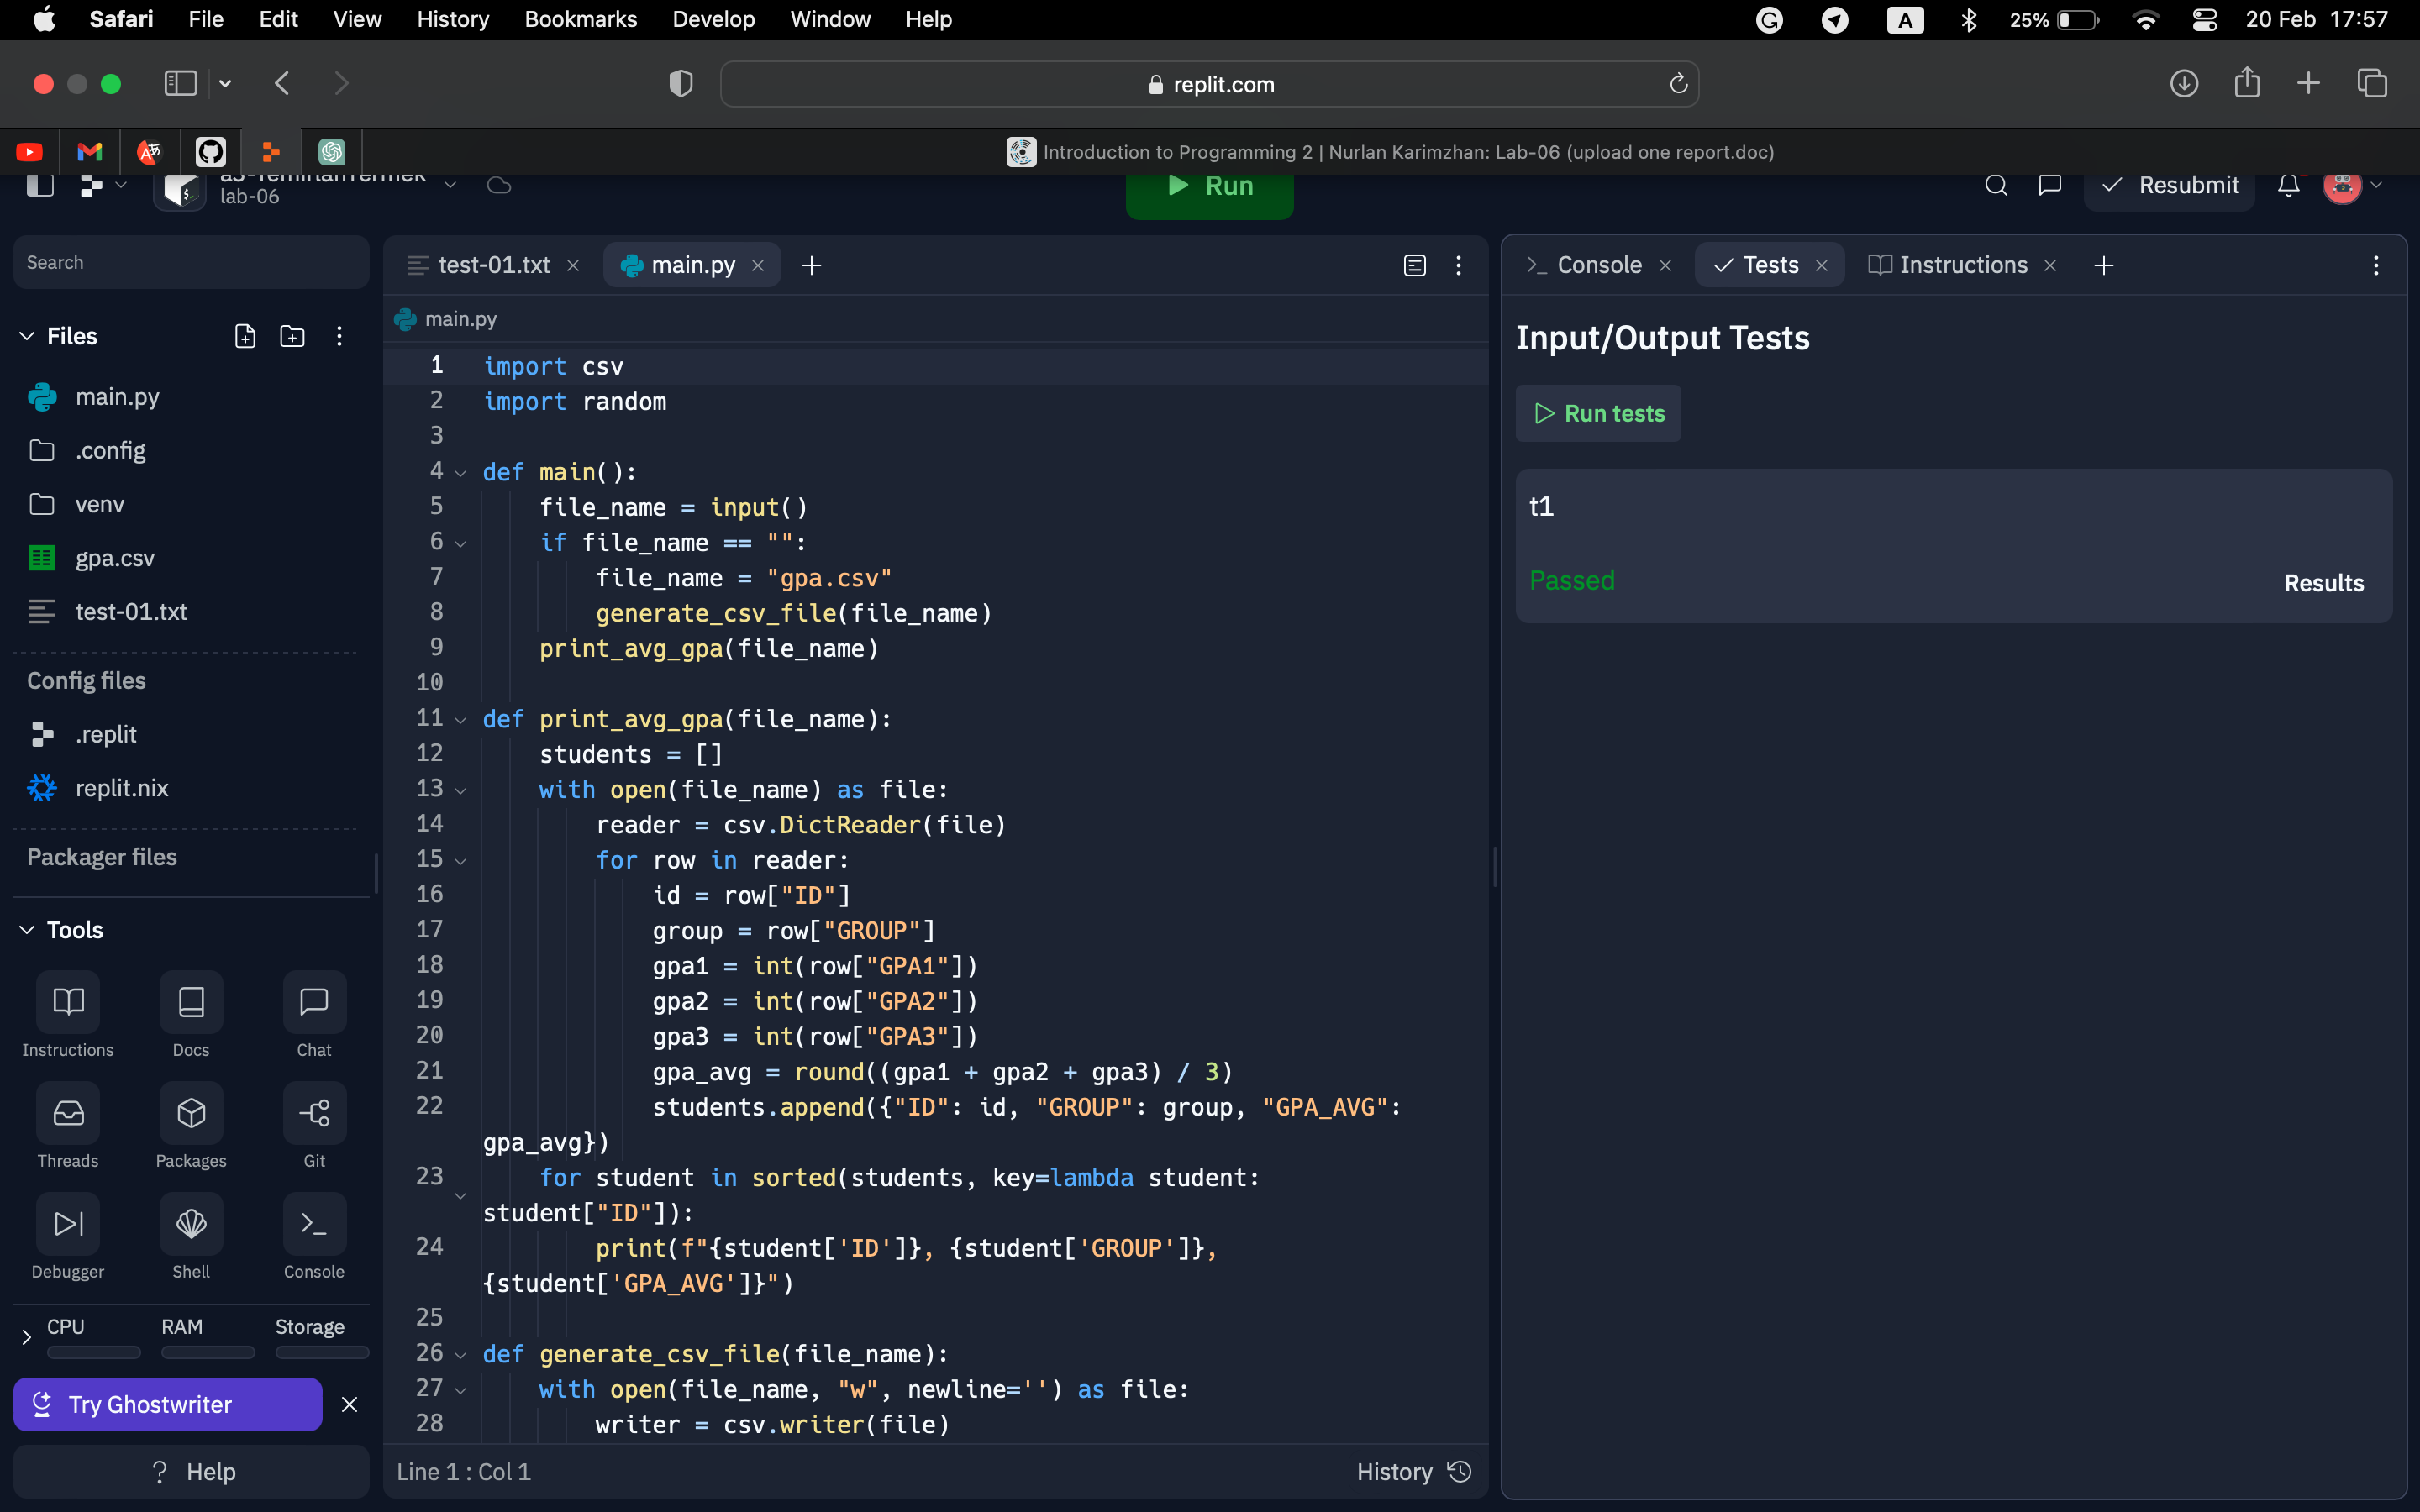

Problem – a4

import re

def main():

phone = input("Phone number: ").strip()

print(validate(phone))

def validate(phone):

pattern = r'^\+\d\(\d{3}\)-\d{3}-\d{4}$'

match = re.search(pattern, phone)

return match is not None

main()

Problem – a5

import re

def main():

address = input("Address: ").strip()

print(validate(address))

def validate(address):

pattern = r'(?i)^[\w\s]+ st\. \d+, apt\. \d+, zip \d{6}$'

match = re.search(pattern, address.replace(" ", " "))

return match is not None

main()

Problem – a6

import re

def main():

print(recognize(input("Data Structure: ")))

def recognize(ds):

list_pattern = r"^\[([\d.,\s]+)\]$"

tuple_pattern = r"^\((.*)\)$"

set_pattern = r"^\{([\w.,\s]+)\}$"

dict_pattern = r"^{([\w\d\s:'\",.\s]+)}$"

list_match = re.match(list_pattern, ds)

tuple_match = re.match(tuple_pattern, ds)

set_match = re.match(set_pattern, ds)

dict_match = re.match(dict_pattern, ds)

if list_match:

values = list_match.group(1).split(",")

if all(re.match(r"^\d+(.\d+)?$", v.strip()) for v in values):

return "List with Float"

elif tuple_match:

values = tuple_match.group(1).split(",")

if all(re.match(r"^[\w\s.'-]+$", v.strip()) for v in values):

return "Tuple with String"

elif set_match:

values = set_match.group(1).split(",")

if all(re.match(r"^\d+(\.\d+)?$", v.strip()) for v in values):

return "Set with Float"

elif dict_match:

values = dict_match.group(1).split(",")

if all(re.match(r"^\d+$", k.strip()) and re.match(r"^\d+$", v.strip()) for k, v in [p.split(":") for p in values]):

return "Dictionary with Integer"

return None

main()

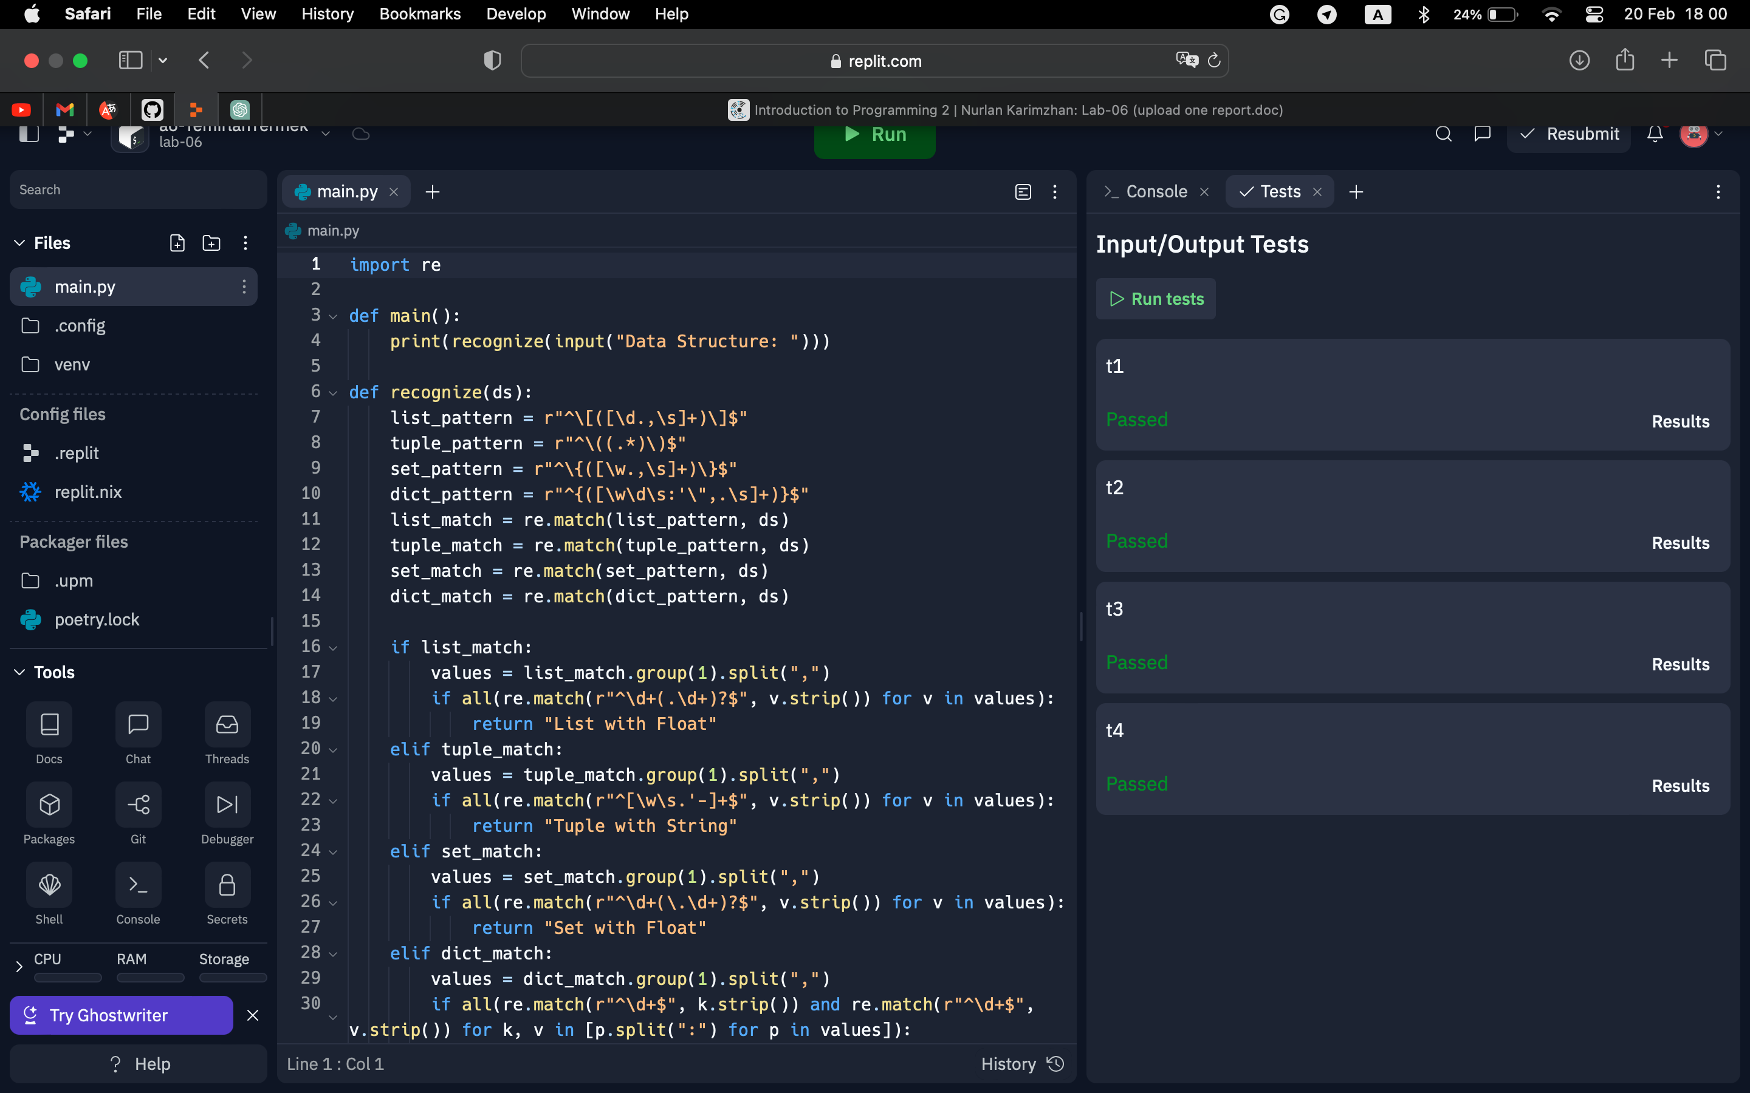

Problem – a7

import re

def validate(ip):

pattern = r"^((\d|[1-9]\d|1\d{2}|2[0-4]\d|25[0-5]).){3}(\d|[1-9]\d|1\d{2}|2[0-4]\d|25[0-5])$"

if re.match(pattern, ip):

return True

else:

return False

def main():

ip_address = input("IPv4 address: ")

is_valid = validate(ip_address)

if is_valid:

print(True)

else:

print(False)

main()

Problem – a8

def count_lines_of_code(filename):

try:

with open(filename) as f:

lines = f.readlines()

except FileNotFoundError:

print(f"Error: File '{filename}' does not exist.")

return 0

lines = [line for line in lines if line.strip() and not line.startswith("#")]

return len(lines)

filename = input("Enter filename: ")

count = count_lines_of_code(filename)

print(count)

Problem – a9

import csv

from tabulate import tabulate

def main():

filename = input("Enter the filename: ")

try:

with open(filename, newline='') as csvfile:

reader = csv.reader(csvfile)

table = []

for row in reader:

table.append(row)

print(tabulate(table, headers='firstrow',tablefmt='grid'))

except FileNotFoundError:

print("Error: File does not exist")

if __name__ == '__main__':

main()

